TITLE
Washing Machine with ESP-32 and IoT Integration
AUTHORS
Syed Namir Bin Syed Ahmad, Rauqah Shafinaz Binti Rizal Shihanaz, Shareefah Humaira Binti Basheerudin, Department of Mechatronics Engineering, International Islamic University Malaysia (IIUM) Email: https://github.com/Syed-Namir

ABSTRACT
This paper presents the design and implementation of a smart washing machine system with ESP-32 and IoT integration, aimed at improving automation, remote monitoring, and user convenience in household laundry operations. The system is built on a layered embedded architecture where the ESP-32 microcontroller serves as the central controller, managing real-time sensing, actuator control, and wireless communication. Key operational parameters such as lid sensor, drum motion, washing time, and motor status are monitored using multiple sensors, while relays and motor drivers regulate washing cycles and load operation. Through Wi-Fi connectivity, the washing machine interfaces with an IoT platform, enabling users to remotely start, stop, and monitor washing processes via a mobile or web-based application. Experimental results demonstrate stable wireless communication, accurate sensor feedback, and responsive system control, validating the effectiveness of ESP-32–based IoT integration for smart home appliance applications.

1.0 INTRODUCTION
Washing machines are essential household appliances that contribute significantly to maintaining hygiene and improving quality of life. Conventional washing machines, however, often rely on manual operation and basic control mechanisms, requiring users to be physically present to start or stop washing cycles. This limitation can be inconvenient for users who prefer remote access or greater control flexibility. With the advancement of Internet of Things (IoT) technologies, there is growing interest in integrating basic connectivity and automation features into household appliances to enhance user convenience.
Traditional washing machines typically operate through manual buttons or fixed control panels, with limited safety features and no remote accessibility. Users may unintentionally operate the machine when the lid is open, which can pose safety risks and lead to improper operation. In addition, the absence of simple alert mechanisms may prevent users from being aware of the machine’s operational status. These issues highlight the importance of incorporating basic sensing and user feedback mechanisms to improve operational safety and usability.
Recent developments in embedded systems have enabled simple yet effective smart appliance implementations using microcontrollers and wireless communication. By integrating sensors and actuators with a microcontroller, essential safety features such as lid detection and audible alerts can be implemented. Furthermore, wireless platforms such as mobile applications allow users to remotely control appliance operations, offering flexibility without requiring complex sensing or data processing systems.
The ESP-32 microcontroller is well suited for such applications due to its built-in Wi-Fi capability, compact design, and ease of integration with IoT platforms. Through wireless connectivity, the ESP-32 can interface with applications such as Blynk, allowing users to manually control the washing machine functions remotely. A buzzer can be incorporated to provide audible alerts during specific operating conditions, while a lid sensor ensures that the machine operates only when the lid is properly closed, enhancing user safety.
This project involves the development of a Smart Washing Machine System using ESP32 and IoT integration, focusing on safe operation and remote controllability rather than advanced sensing. The system uses a lid detection sensor to prevent operation when the lid is open, a buzzer and visual indicators for user feedback, and a Blynk mobile application to allow remote control of washing modes. The project demonstrates a practical application of Mechatronics System Integration by combining sensing, actuation, embedded control, and IoT connectivity in a single functional prototype.

2.0 METHODOLOGY
2.1 Project Development
The overall system architecture is designed as an integrated mechatronic solution that synchronizes human-machine interface (HMI) elements with high-power mechanical sub-assemblies. At the core of the architecture, the ESP32 manages the data flow between the input peripherals comprising the 4x4 keypad and water level sensor and the output control modules. The power distribution network is segmented to handle various voltage requirements, utilizing a dedicated power supply unit to provide stable 12V and 24V rails for the motors while maintaining a regulated 5V bus for the microcontroller and logic circuitry. Communication between the central controller and the visual display is established via the I2C protocol. The firmware was developed using Arduino Ide. The startTask() function was defined to set the specific duration, motor speed, pump status for each cycle. Motor agitation was implemented at the “Wash” and “Rinse” mode and a soft star implementation to prevent high current in rush during the “spin” cycle, where a ramping algorithm was used to incrementally increase the PWM values protecting the microcontroller from voltage drop. IoT function was also integrated using the Blynk app where virtual pins V1 to V5 were mapped to the physical button functions allowing control from both the mobile application and hardware interface.

Fig.1 Flowchart of the washing machine

2.2 Schematic Diagram and Prototype Setup
Fig.2 Block Diagram of the washing machine system

Fig.3 Prototype setup of the washing machine
Fig.4 Electrical diagram of the washing machine

3.0 HARDWARE AND CONTROL LOGIC

3.1 Hardware Architecture
This project integrates multiple hardware components, each fulfilling a specific mechatronic role within the system.
The ESP32 microcontroller acts as the central controller, responsible for executing control logic, generating PWM signals for motor control, managing safety checks, and providing Wi-Fi connectivity for IoT integration. Its built-in wireless capability allows seamless communication with the Blynk cloud platform.
The Cytron Robo ESP32 motor driver is used as the actuator interface. It drives the DC motor responsible for washing drum movement and supports bidirectional control as well as variable speed operation using PWM signals generated by the ESP32.
For safety sensing, an HC-SR04 ultrasonic sensor is employed to detect the lid position. The sensor continuously measures the distance between the lid and the sensor, allowing the system to determine whether the lid is closed or open before and during operation.
User interaction is provided through a 16×2 I2C LCD, tactile buttons, LEDs, and a piezo buzzer. The LCD displays system states and selected washing modes, while the buzzer and LED provide audible and visual feedback during operation and cycle completion.
IoT connectivity is achieved through the Blynk platform, which allows users to remotely start, stop, and select washing modes using a smartphone application.

3.2 Operational Modes
The system software is designed to support three main washing modes, each defined by specific motor speed, direction, and timing parameters tailored for this prototype.
Wash Mode operates the motor at a low speed with alternating clockwise and counterclockwise rotation, simulating the scrubbing action required for effective washing while minimizing mechanical stress. This mode is intended for washing clothes with detergent to remove dirt and stains. In this prototype, the wash cycle runs for 10 seconds.
Rinse Mode uses a moderate motor speed with repeated agitation cycles to rinse the clothes. The key difference from Wash Mode is that no detergent is used, and the purpose is solely to remove remaining detergent or soap from the fabrics. Although no water level sensing is implemented, the timing logic ensures a consistent rinsing sequence. The rinse cycle duration is set to 10 seconds in this prototype.
Spin Mode operates the motor at high speed in a single direction. To protect the motor and driver, a PWM ramp-up (soft-start) technique is implemented. The PWM duty cycle gradually increases from a low value to the maximum value, preventing high inrush current and sudden mechanical jerk. The spin cycle runs for 15 seconds, allowing sufficient time for drum rotation while maintaining motor safety.

3.3 Arduino Code
#include <Wire.h>
#include <LiquidCrystal_I2C.h>
#include <WiFi.h>
#include <WiFiClient.h>
#include <BlynkSimpleEsp32.h>

// Blynk Credentials
#define BLYNK_TEMPLATE_ID "TMPL6ZRP20wKo"
#define BLYNK_TEMPLATE_NAME "Washing machine"
#define BLYNK_AUTH_TOKEN "earIUxwIWZ2G3m-wGpWK654Xa4CV0Sey"

char auth[] = BLYNK_AUTH_TOKEN;
char ssid[] = "Feang";
char pass[] = "messi123";

// --- PIN MAPPING ---
const int M1A = 12;
const int M1B = 13;
const int PIN_PUMP = 27;
const int PIN_TRIG = 16;
const int PIN_ECHO = 17;

const int BTN_START = 15;
const int BTN_WASH = 25;
const int BTN_RINSE = 4;
const int BTN_SPIN = 5;
const int BTN_PAUSE = 18;
const int buzzerPin = 23;
LiquidCrystal_I2C lcd(0x27, 16, 2);

// --- VARIABLES ---
long remainingTime = 0;
bool isPaused = false;
bool isRunning = false;
unsigned long lastTick = 0;
String currentMode = "";
int motorSpeed = 0;
int currentRampSpeed = 0; // NEW: Variable to track current speed during ramp-up

// --- BLYNK VIRTUAL PIN CONTROLS ---
BLYNK_WRITE(V1) { if(param.asInt()) handleStart(); }
BLYNK_WRITE(V2) { if(param.asInt() && !isRunning) startTask("Washing", 15, 95, true); }
BLYNK_WRITE(V3) { if(param.asInt() && !isRunning) startTask("Rinsing", 10, 95, true); }
BLYNK_WRITE(V4) { if(param.asInt() && !isRunning) startTask("Spinning", 15, 255, false); }
BLYNK_WRITE(V5) { if(param.asInt()) togglePause(); }

void setup() {
lcd.init();
lcd.backlight();
lcd.clear();

pinMode(M1A, OUTPUT);
pinMode(M1B, OUTPUT);
pinMode(PIN_PUMP, OUTPUT);
pinMode(PIN_TRIG, OUTPUT);
pinMode(PIN_ECHO, INPUT);
pinMode(buzzerPin, OUTPUT);

pinMode(BTN_START, INPUT_PULLUP);
pinMode(BTN_WASH, INPUT_PULLUP);
pinMode(BTN_RINSE, INPUT_PULLUP);
pinMode(BTN_SPIN, INPUT_PULLUP);
pinMode(BTN_PAUSE, INPUT_PULLUP);

lcd.print("WiFi Connecting");
Blynk.begin(auth, ssid, pass);
lcd.clear();
lcd.print("System Ready");
delay(2000);
lcd.clear();
lcd.print("Press START");
}

void loop() {
Blynk.run();
checkPhysicalButtons();

if (isRunning) {
runWashingCycle();
}
}

void handleStart() {
lcd.clear();
lcd.print("Choose Mode:");
}

void togglePause() {
isPaused = !isPaused;
if (isPaused) {
stopMotor();
digitalWrite(PIN_PUMP, LOW);
lcd.setCursor(0, 1);
lcd.print("PAUSED ");
}
}

void checkPhysicalButtons() {
if (digitalRead(BTN_PAUSE) == LOW) {
delay(200);
togglePause();
while(digitalRead(BTN_PAUSE) == LOW);
}

if (!isRunning) {
if (digitalRead(BTN_START) == LOW) {
delay(200);
handleStart();
}
if (digitalRead(BTN_WASH) == LOW) startTask("Washing", 15, 95, true);
if (digitalRead(BTN_RINSE) == LOW) startTask("Rinsing", 10, 95, true);
if (digitalRead(BTN_SPIN) == LOW) startTask("Spinning", 15, 255, false);
}
}

void startTask(String mode, int seconds, int speed, bool usePump) {
currentMode = mode;
motorSpeed = speed;
currentRampSpeed = 0; // NEW: Reset ramp speed at the start of every task
remainingTime = (long)seconds * 1000;
isRunning = true;
isPaused = false;
lastTick = millis();

lcd.clear();
lcd.print(mode);

if (usePump) {
digitalWrite(PIN_PUMP, HIGH);
lcd.setCursor(0, 1);
lcd.print("Filling Water...");
delay(3000);
digitalWrite(PIN_PUMP, LOW);
}
}

bool lidClosed() {
digitalWrite(PIN_TRIG, LOW);
delayMicroseconds(2);
digitalWrite(PIN_TRIG, HIGH);
delayMicroseconds(10);
digitalWrite(PIN_TRIG, LOW);
long duration = pulseIn(PIN_ECHO, HIGH);
return (duration * 0.034 / 2 < 10);
}

void stopMotor() {
analogWrite(M1A, 0);
analogWrite(M1B, 0);
currentRampSpeed = 0; // Reset ramp speed when stopping
}

void runWashingCycle() {
if (isPaused) return;

if (!lidClosed()) {
stopMotor();
lcd.setCursor(0, 1);
lcd.print("CLOSE LID! ");
return;
}
if (currentMode == "Washing" || currentMode == "Rinsing") {
int cycle = (millis() / 1000) % 5;
if (cycle < 2) { analogWrite(M1A, motorSpeed); analogWrite(M1B, 0); }
else if (cycle == 2) { stopMotor(); }
else { analogWrite(M1A, 0); analogWrite(M1B, motorSpeed); }
}
// --- START OF HIGHLIGHTED RAMP-UP PART ---
else if (currentMode == "Spinning") {
if (currentRampSpeed < motorSpeed) {
currentRampSpeed++; // Increment PWM speed by 1
delay(15); // Delay to control how fast the motor ramps up (Approx 3.8s to reach full)
}
analogWrite(M1A, currentRampSpeed);
analogWrite(M1B, 0);
}
// --- END OF HIGHLIGHTED RAMP-UP PART ---

if (millis() - lastTick >= 1000) {
remainingTime -= 1000;
lastTick = millis();
lcd.setCursor(0, 1);
lcd.print("Time: "); lcd.print(remainingTime / 1000); lcd.print("s ");
Blynk.virtualWrite(V6, remainingTime / 1000);
}

if (remainingTime <= 0) {
stopMotor();
isRunning = false;
lcd.clear();
lcd.print("DONE");
for(int i=0; i<3; i++) {
tone(buzzerPin, 1000, 100); delay(200);
tone(buzzerPin, 500, 100); delay(200);
}
delay(2000);
lcd.clear();
lcd.print("Press START");
}
}

4. SYSTEM INTEGRATION AND FEATURES
4.1 IoT and Remote Control Integrations
The prototype uses ESP32 built in Wi-Fi to initiate a connection with Blynk IoT platform that allows to for a “Digital Twin” control scheme. Virtual Pins were mapped out to send the same signal as the physical button when pressed enabling the LCD to work as if the physical button is pressed allowing for the washing machine to start or paused through smartphone
Status updates are synchronised between the physical LCD and the Blynk app dashboard in real time
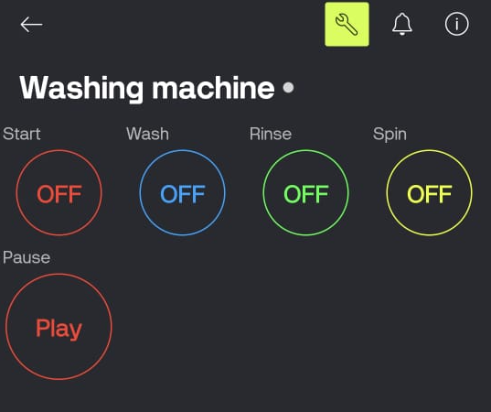

4.2 Safety Interlock System
A critical feature of the integration is the safety protocol managed by the HC-SR04 ultrasonic sensor.
Logic: The sensor continuously measures the distance to the lid. If the distance exceeds a pre-defined threshold (indicating the lid is open), the ESP32 triggers an immediate interrupt to the Cytron Robo ESP32 driver, cutting power to the motor.
User Protection: This prevents mechanical injury during high-speed operations, specifically the spin cycle.
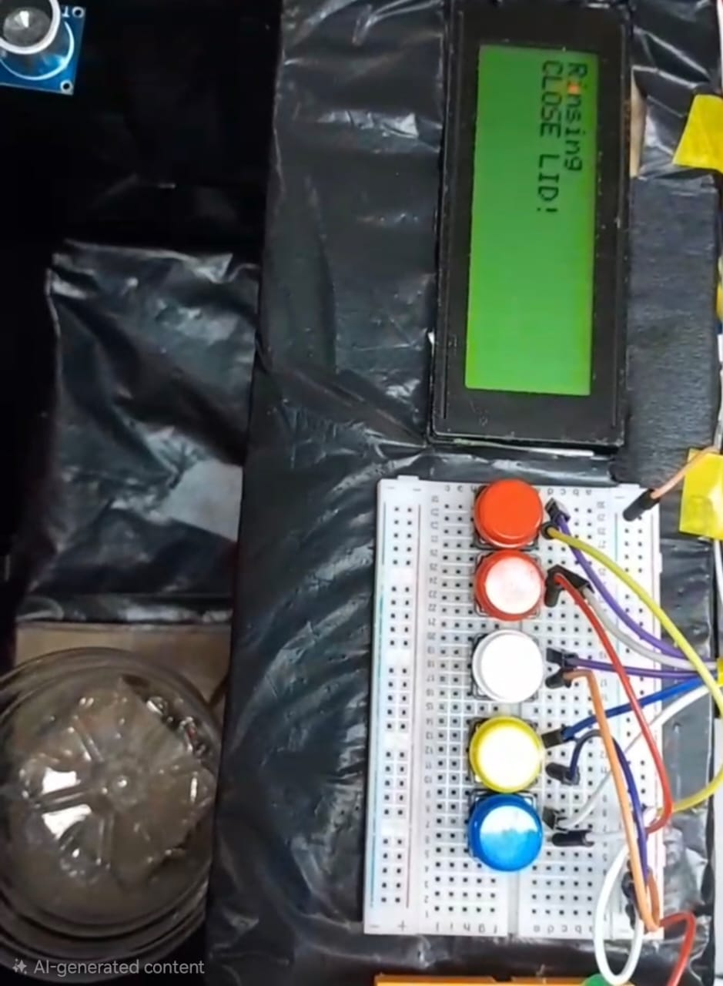
If Distance < Threshold (Lid Closed) Operation continues.
If Distance > Threshold (Lid Open) Motor stops immediately and LCD displays a warning.
4.3 Advanced Motor Control Logic
Agitation (Wash/Rinse): The system uses timed directional switching, alternating the motor polarity to simulate mechanical scrubbing.
PWM Ramp-Up (Spin): To prevent motor burnout and mechanical fatigue, the spin cycle does not start at 100% duty cycle. Instead, the code implements a linear PWM ramp-up, gradually increasing torque until maximum centrifugal speed is reached.
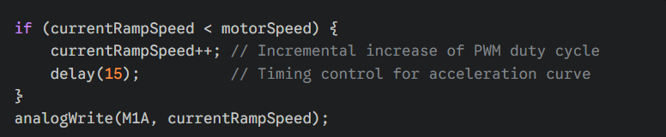

4.4 Operational Pause and Resume Feature
To enhance user control and operational safety, the system incorporates a global pause state. This feature can be triggered via a physical tactile button or the Blynk mobile app.
State Management: When the pause is activated, the ESP32 sets a boolean flag (isPaused) that immediately bypasses the motor control and timer countdown functions.
User Feedback: The 16x2 LCD updates to display "PAUSED", providing clear visual confirmation of the system state.
Persistence: Unlike a full system reset, the pause state holds the remainingTime variable in memory. Once the pause button is toggled again, the system resumes the operation exactly from where it was interrupted, ensuring the wash cycle is completed accurately.

4.5 User Feedback Loop
Once the cycle is completed the ESP 32 triggers a pulse sending it to the buzzer where the buzzer plays a short melody then and blinking led. The ESP then sends a signal to display “Press Start” on the LCD screen allowing the user to restart the washing machine and choose the next function

5. RESULT AND DISCUSSION
5.1 Performance Verification
The system was tested across all three modes (Wash, Rinse, Spin). The Cytron Robo ESP32 effectively managed the current spikes during the agitation phase. The PWM ramp-up successfully mitigated the "jerk" typically seen in DC motors, resulting in a smoother transition to high speeds.
5.2 Sensor Reliability
The ultrasonic sensor provided a reliable non-contact solution for lid detection. During testing, the system demonstrated a latency of less than 200ms between opening the lid and the motor coming to a complete stop.
5.3 Connectivity Analysis
Remote operation via Blynk was successful within a standard Wi-Fi range. The transition between physical button presses and virtual button commands showed no logic conflicts, confirming that the code's state machine effectively prioritized the most recent user input.

6. CONCLUSION
The development of the ESP32-based Smart Washing Machine prototype successfully demonstrates the seamless integration of mechanical actuation, electronic sensing, and IoT-based control. By utilizing the ESP32 microcontroller in conjunction with the Cytron Robo ESP32 driver, the project achieved a robust control system capable of managing high-current DC motors while maintaining precise timing and user safety.
A primary achievement of this project was the implementation of specialized motor control algorithms. The use of bidirectional agitation for the Wash and Rinse cycles effectively simulated real-world mechanical cleaning actions. Furthermore, the integration of a PWM Ramp-Up (Soft-Start) feature for the high-speed Spin cycle proved essential in protecting the motor from electrical inrush current and reducing mechanical fatigue on the prototype’s drivetrain. This demonstrates an understanding of the electrical and mechanical limitations inherent in mechatronic systems.
Safety was prioritized through the application of an HC-SR04 ultrasonic sensor, which served as a non-contact safety interlock. The system logic ensured that any breach of the "lid-closed" threshold resulted in an immediate emergency stop, highlighting the importance of fail-safe mechanisms in consumer appliance design. Additionally, the dual-interface control combining physical tactile buttons with the Blynk IoT platform successfully bridged the gap between traditional hardware and modern Cyber-Physical Systems (CPS). The ability to monitor cycle progress and pause the machine remotely via Wi-Fi adds a layer of modern utility expected in Industry 4.0 applications.
In summary, the prototype met all project objectives, validating the effectiveness of the chosen hardware architecture and software logic. While the current system provides a solid foundation for an automated appliance, future iterations could be enhanced by integrating water-level pressure sensors and load-balancing accelerometers to further refine the machine's autonomy and efficiency. Ultimately, this project serves as a comprehensive example of how mechatronics can transform a standard mechanical process into an intelligent, safe, and connected system.

REFERENCES
[1] DIY How to make Washing Machine from Cardboard. (2018). YouTube; Target Engineer. Available: https://youtu.be/nzLVk48a9uE?si=4OWJM55J4puF3-qT
[2] H. Hercog, T. Lerher, M. Truntič, and O. Težak, “Design and Implementation of ESP32-Based IoT Devices,” Sensors, vol. 23, no. 15, p. 6739, 2023. DOI: https://doi.org/10.3390/s23156739
[3] How to Build a Washing Machine. (2020). YouTube; Liberman. Available: https://youtu.be/T014PFSVR5E?si=_PBEB57DKO2g_Dfy
[4] How to set up the new Blynk app with an ESP32 board | ESP32 projects. (2023). YouTube; SriTu Hobby. Available: https://youtu.be/W1xG_XJb0FU?si=HH3Ha6YGb6FyV-4l
[5] A. Jeevarathinam and J. Adinarayan, “Smart Motion Detection System Using ESP32 and Ultrasonic Sensor,” International Scientific Journal of Engineering and Management, vol. 4, no. 10, pp. 1–9, 2025. DOI: https://doi.org/10.55041/isjem05080
[6] Robo ESP32: Simplifying Smart Projects with ESP32. (2025). YouTube; Cytron Technologies. Available: https://youtu.be/vX8lKd5gWfo?si=R5k1NC-6oQ_V2Ph3
[7] “Seamless Integration of ESP32-Based Sensor Networks and Cloud Platforms for Modern Home Automation,” International Research Journal of Modernization in Engineering Technology & Science, 2025. DOI: https://doi.org/10.56726/irjmets85316
[8] T. Hariono, S. P. Indryanto, M. Munawarah, and H. Ashoumi, “Conversion Design of Arduino-Based Semi-Automatic Clothes Washer,” NEWTON Networking and Information Technology, vol. 3, no. 2, pp. 1–5, 2024. DOI: https://doi.org/10.32764/newton.v3i2.4578

